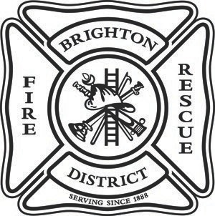
Brighton Fire Rescue District
500 South 4th Avenue, 3rd Floor • Brighton, Colorado 80601
Telephone: (303) 659-4101 • Fax: (303) 659-4103 • Website: www.brightonfire.org

NOTICE OF SPECIAL BOARD MEETING AND PROPOSED AGENDA

Wednesday – May 24, 2023 – 5:30 p.m.

The agenda is preliminary and subject to change by a majority vote of the Board at the meeting.
Meetings will be held in person and via electronic participation. Details for participating virtually are below:
Join Zoom Meeting https://zoom.us/j/98258047861 Meeting ID: 982 5804 7861
One tap mobile
+16699006833,98258047861# US (San Jose)
+12532158782,98258047861# US (Tacoma)
Individuals requiring special accommodation to attend and/or participate in the meeting should advise the Administrative Assistant at (303) 659-4101 of their specific need(s) 48 hours before the meeting. This meeting is open to the public.

AGENDA
- Call to Order

- Roll Call

- Call for changes to and approval of the Agenda.

- Administrative Items
- Board Training
- Policy discussion of Section 2 T
- Branding discussion
- Planning discussion

- Other businesses that may come before the Board.

- Adjournment

